Parking Efficiency Integration

CSUSB Parking

Team Members:

Sally Phang

James Huang

James Small

Leigh-Anna Griswould

***Vision / Business Case***

Any student who has a class at midday can tell you that finding a parking spot can be difficult at best. What if there was a way to help increase the efficiency of the existing parking lots along with directing students to parking lots with available spots. What we are proposing is a queuing system for each parking lot that keeps track of incoming and outgoing cars and compares those numbers with the number of total parking spots for that lot. These numbers will be updated in real time and will also be displayed at each intersection that leads to a parking lot. There will also be a board at the main intersection that displays the parking statistics for every lot on campus. Utilizing a system such as this can help increase the efficiency of each parking lot while decreasing the need to construct more parking structures. The system can also be used to control the flow of traffic around the campus.

***Fully Dressed Use Cases:***

**Name:** Parking Sign Displays Status to Driver

**Scope:** The system in action.

**Level:** User Notification.

**Primary Actor:** Parking Sign.

**Secondary Actor:** Driver

**Stakeholders and Interests:** Driver, Parking Services, The University.

**Preconditions:** Sign and sensors must display accurate information on the parking lot.

**Post conditions:** Sign reflects that there are spots available so the student enters lot and parks.

**Main Success Scenario:**

1: User looks at sign.

2: Sign reports that there are spots available in this parking area.

3: User enters parking area and parks.

4: Database is updated with new count.

4: Sign Display is modified based on updated count

**Extensions:**

2a: Sign reports that there are no empty spots available.

2aa: User does not enter parking lot.

2ab: User checks a different parking area.

**Name:** Vehicle driving over sensor entering parking lot

**Scope:** The system in action.

**Level:** User Goal

**Primary Actor:** Driver

**Stakeholders and Interests:** Driver, Parking Services, the University

**Preconditions:** Weight of the vehicle must trigger the sensor. Vehicle must enter parking lot where it is designated as an entrance.

**Post conditions:** Sign is updated to reflect the number of available spots.

**Main Success Scenario:**

1: User approaches the entrance to the parking lot.

2: Underground sensor identifies the weight as a car and is logged.

3: Database is updated with new count by subtracting count by one.

4: Sign Display is modified based on updated count.

**Extensions:**

2a: Vehicle does not weigh enough to trigger the sensor.

2aa: A sensor that is broken will not log the action.

**Special Requirements:** Sensors must be functional and vehicle must weigh a certain amount to trigger the sensors.

**Frequency of occurrence:** This occurs every time a student tries to enter the parking area.

**Name:** Vehicle driving over sensor leaving parking lot

**Scope:** The system in action.

**Level:** User Goal.

**Primary Actor:** Driver

**Stakeholders and Interests:** Driver, Parking Services, the University

**Preconditions:** Weight of the vehicle must trigger the sensor. Vehicle must leave parking lot where it is designated for exiting.

**Post conditions:** Sign is updated to reflect the number of available spots.

**Main Success Scenario:**

1: User is finished using the parking lot.

2: User will drive over the sensor at the parking lot exit to leave the parking lot and is logged.

3: Database is updated with new count by adding count by one.

4: Sign Display is modified based on updated count.

**Extensions:**

2a: Vehicle does not weigh enough to trigger the sensor.

2aa: A sensor that is broken will not log the action.

3a: Vehicle does not drive out of a parking lot without using road, action is not logged.

**Special Requirements:** Sensors must be functional and vehicle must weigh a certain amount to trigger the sensors.

**Frequency of occurrence:** This occurs every time a student tries to leave the parking area.

2b: Sign shows parking lot full with no available spots.

2ba: User enters full lot.

2bb: Sign reflects negative number stating that parking area is overflowing.

**Special Requirements:** Parking lot has to be open.

**Frequency of occurrence:** This occurs every time a student tries to enter the parking area.

**Miscellaneous:** Could possible look into using RFID tags to specify which type (handicapped, carpool, etc) of spots are open.

***Casual Use Cases:***

**Name:** Vehicle Drives over sensor entering Parking Structure

**Main Success Scenario:** A vehicle drives over the parking sensor to enter the parking structure. The action is logged and then reflected in the number of available spots displayed on the sign by subtracting 1 from the total available for that particular parking structure.

**Alternate Scenario 1:** If the vehicle doesn’t weight enough to trigger the sensor, the count will be off by 1. The action will not be logged and maintenance will have to be done to adjust the count to the correct total.

**Alternate Scenario 2:** If the vehicle drives over a sensor that is broken, the action is not logged and the number of available spots being displayed will be incorrect.

This problem will remain until maintenance has been completed to fix the issue.

**Alternate Scenario 3:** If the vehicle drives out of a parking structure by using the entrance instead of the exit, the action is logged in as a car entering the structure and the number of available spots displayed will be incorrect. This problem will remain until maintenance has been completed to fix the issue.

**Name:** Vehicle Drives over sensor exiting Parking Structure

**Main Success Scenario:** A vehicle drives over the parking sensor to exit the parking structure. The action is logged and then reflected in the number of available spots displayed on the sign by adding 1 from the total available for that particular parking structure.

**Alternate Scenario 1:** If the vehicle doesn’t weight enough to trigger the sensor, the count will be off by 1. The action will not be logged and maintenance will have to be done to adjust the count to the correct total.

**Alternate Scenario 2:** If the vehicle drives over a sensor that is broken, the action is not logged and the number of available spots being displayed will be incorrect. This problem will remain until maintenance has been completed to fix the issue.

**Alternate Scenario 3:** If the vehicle drives out of a parking structure by using the entrance instead of the exit, the action is logged in as a car entering the structure and the number of available spots displayed will be incorrect. This problem will remain until maintenance has been completed to fix the issue.

**Name:** Vehicle Drives over sensor entering Parking Structure Level

**Main Success Scenario:** A vehicle drives over the parking sensor to enter the parking structure level. The action is logged and then reflected in the number of available spots displayed on the sign by subtracting 1 from the total available for that particular parking structure level.

**Alternate Scenario 1:** If the vehicle doesn’t weight enough to trigger the sensor, the count will be off by 1. The action will not be logged and maintenance will have to be done to adjust the count to the correct total.

**Alternate Scenario 2:** If the vehicle drives over a sensor that is broken, the action is not logged and the number of available spots being displayed will be incorrect.

This problem will remain until maintenance has been completed to fix the issue.

**Alternate Scenario 3:** If the vehicle drives out of a parking structure level by using the entrance instead of the exit, the action is logged in as a car entering the structure level and the number of available spots displayed will be incorrect. This problem will remain until maintenance has been completed to fix the issue.

**Name:** Vehicle Drives over sensor exiting Parking Structure Level

**Main Success Scenario:** A vehicle drives over the parking sensor to exit the parking structure level. The action is logged and then reflected in the number of available spots displayed on the sign by adding 1 from the total available for that particular parking structure level.

**Alternate Scenario 1:** If the vehicle doesn’t weight enough to trigger the sensor, the count will be off by 1. The action will not be logged and maintenance will have to be done to adjust the count to the correct total.

**Alternate Scenario 2:** If the vehicle drives over a sensor that is broken, the action is not logged and the number of available spots being displayed will be incorrect. This problem will remain until maintenance has been completed to fix the issue.

**Alternate Scenario 3:** If the vehicle drives out of a parking structure level by using the entrance instead of the exit, the action is logged in as a car entering the structure level and the number of available spots displayed will be incorrect. This problem will remain until maintenance has been completed to fix the issue.

**Name:** Adjust Count

**Main Success Scenario:** The administrator for the system needs to change a count for a particular parking lot, parking structure, or parking structure level. After authenticating themselves, they will update the appropriate lot with the corrected count.

**Alternate Scenario 1:** The administrator forgot their password and is unable to login to the system in order to make the change they want to be made. This requires extra work to either remember the password, or have the password changed.

**Alternate Scenario 2:** The administrator changes the count for a particular location incorrectly, and now the system is displaying an incorrect count and requires to be fixed.

***Brief Use Cases:***

**Name:** Backup Data

**Description:** The database containing the current parking counts and system software is backed up to ensure fast recovery in case of a disaster.

***Use Case Diagram***

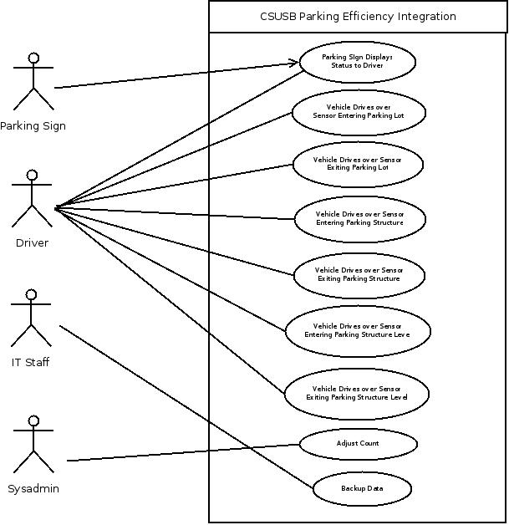

***Supplementary Specifications***

* System must be as close as possible to real time data being updated on the signs as to allow drivers to effectively select the correct location to park. It should also not update too fast as to make it hard to read when the numbers change too rapidly.
* Parking Signs must be properly located to allow maximum viewing by drivers
* Parking Sign displays need to be easily readable, including correct coloring for colorblind individuals.

***Domain Model***

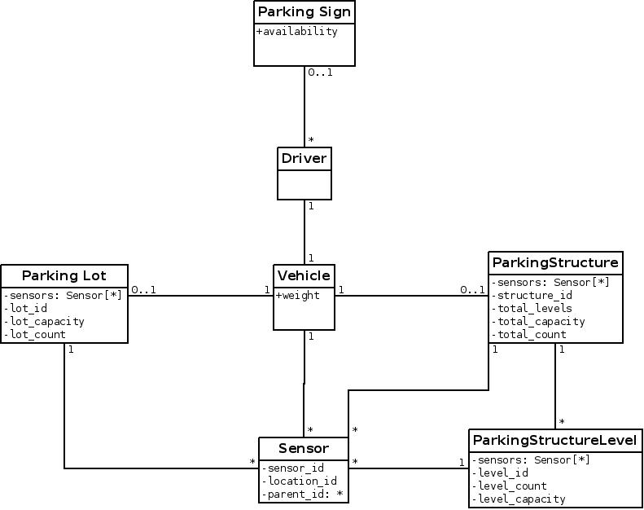

***Package Diagram***

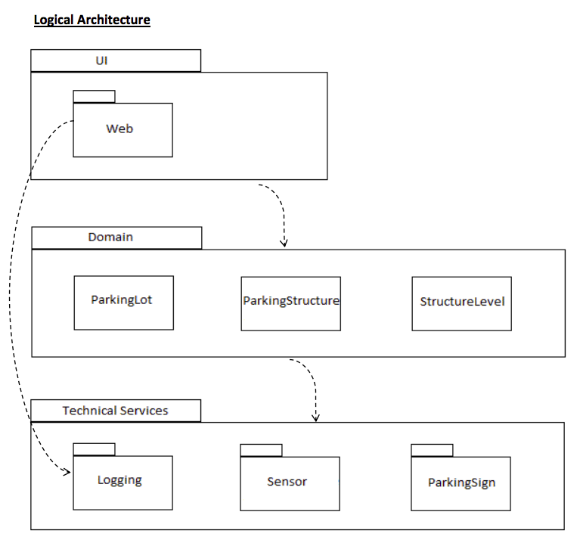

***Glossary***

**Sensor**::=Device underground that can tell when a car drives over it.

**Parking Lot**::= One of many locations on campus where a drive can park, which excludes all Parking Structures.

**Parking Structure**::= One of two locations on campus to park with multiple levels.

**Parking Level**::=Parking Structure= Specific locations within a parking structure where drivers can park, separated by different levels within the structure.

**Main Sign**::=Sign at the entrance of campus that informs drivers of parking availability in every lot or structure on campus

**Structure Sign**::= Sign at the entrance of each parking structure that informs drives of parking availability in the parking structure, and on each Parking Level of the Parking Structure

**Website**::= Website that will be used by administrators of the system to update counts when they’re off, and to disable or turnoff specific lots when they’re currently unavailable.

***Business Rules***

* Only administrators are allowed to access and update counts for parking areas.

***System Sequence Diagrams***

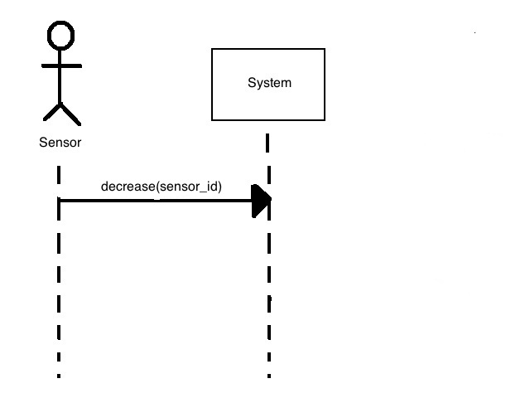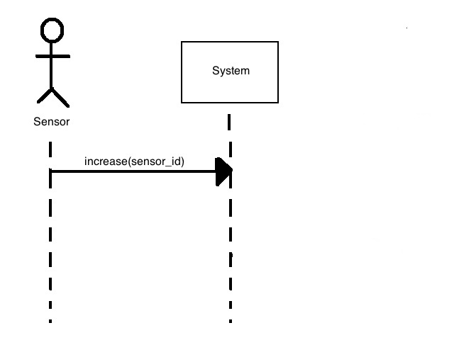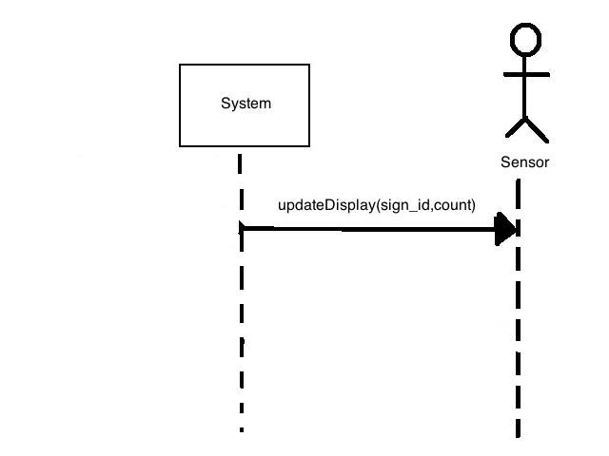

***Interaction Diagrams***

***Vehicle Enters Parking Lot***

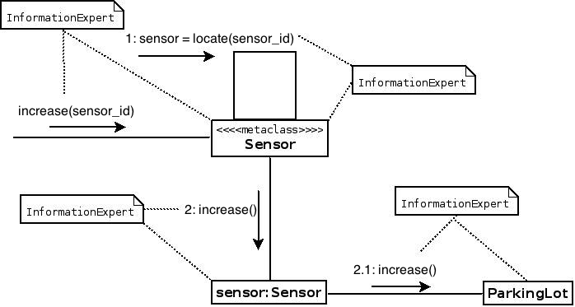

***Vehicle Exits Parking Lot***

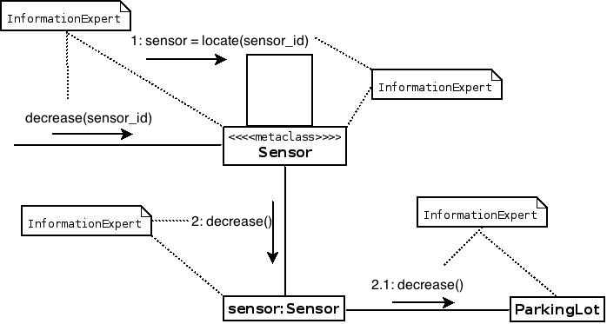

***Admin Updates Parking Count***

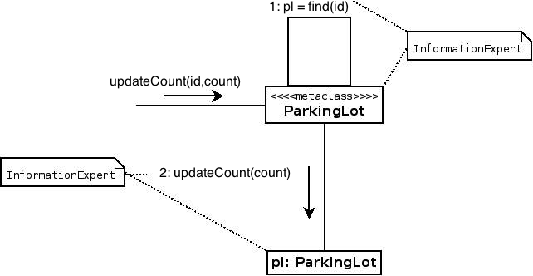

***Design Class Diagram***

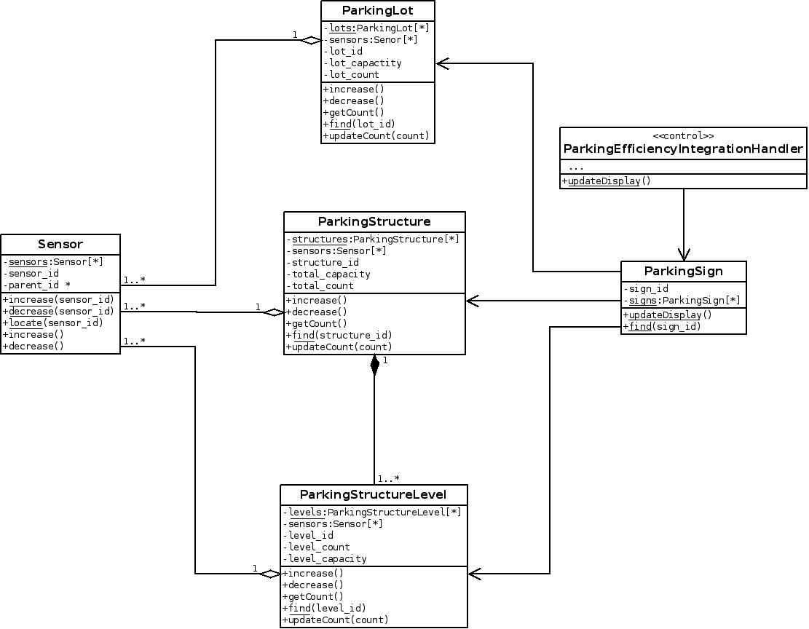

**Grasp Pattern Explanations**

We chose the GRASP pattern “Information Expert” for our interaction diagrams as the main activities that occur in our diagrams involves retrieving and updating information. The information expert idea is useful as it allows us to distinguish who has the correct information we need, and who has the information we need updated. We do utilize the “Controller” pattern for updating the parking signs. The controller in this case manages when we update the signs, as updating them as cars enter and exit would cause the signs to flicker with so many changes and make it hard to read. The controller allows us to make batch updates every few seconds, which allows the drivers to read the signs, better.